**Write the missing words.**

**JOBS (Likes and Dislikes)**

**policewoman – bus driver – vet – doctor – chef – pilot – teacher –farmer – school – restaurant – airport – farm – veterinary clinic – hospital – police station – cooking – animals – flying planes – driving bus – growing vegetables – helping people – teaching – examining patients**

**bilgeceingilizce.weebly.com**

**She is a …………………….**

**She works at a ……………….**

**She likes children and ……………….**



**He is a …………………….**

**He works at a ………………….**

**He likes ……………………….**



**He is a …………………….**

**He works on a ……………….**

**He likes animals and ……………….**



**She is a ………………………….**

**She works at a …………………….**

**She likes ………………………….**

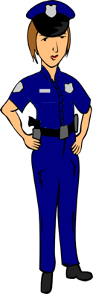

**He is a …………………….**

**He works at an ……………….**

**He likes ………………………….**



**He is a …………………….**

**He likes ……………………….**

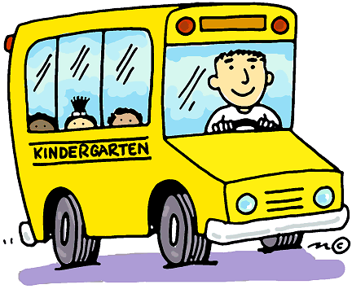

**He is a …………………….**

**He works at a ……………….**

**He likes …………………………….**



**She is a …………………….**

**She works at a ……………….**

**She likes ………………….**

