JOBS

**bilgeceingilizce.weebly.com**

What do you do?

Where do you work?

**I am a ……...**

**I work at a ……...**



**I am a …………**

**I work at a …………**



**I am a ……………**

**I work at a …………**

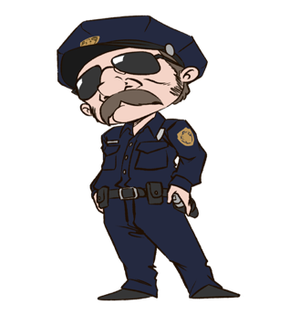

**I am a …………**

**I work on a ………**

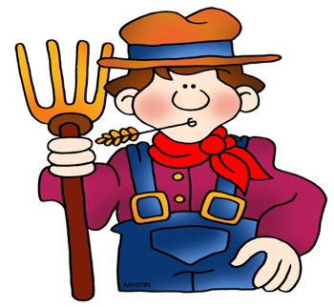

**I am a …………**

**I work at a ………**



**I am an …………**

**I work at a ………**



**I am a …………**

**I work at a …………**



**I am a …………**

**I work at a …………**

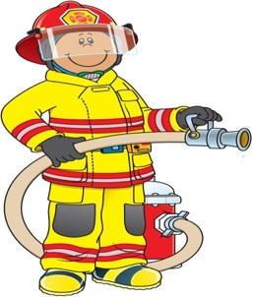

**I am an ………**

**I work at a ………**



**businessman**

**engineer**

**teacher**

**farmer**

**fireman**

**nurse**

**doctor**

**actor**

**policeman**

**theater**

**police**

**station**

**hospital**

**school**

**factory**

**hospital**

**farm**

**fire**

**station**

**company**