bilgeceingilizce.weebly.com

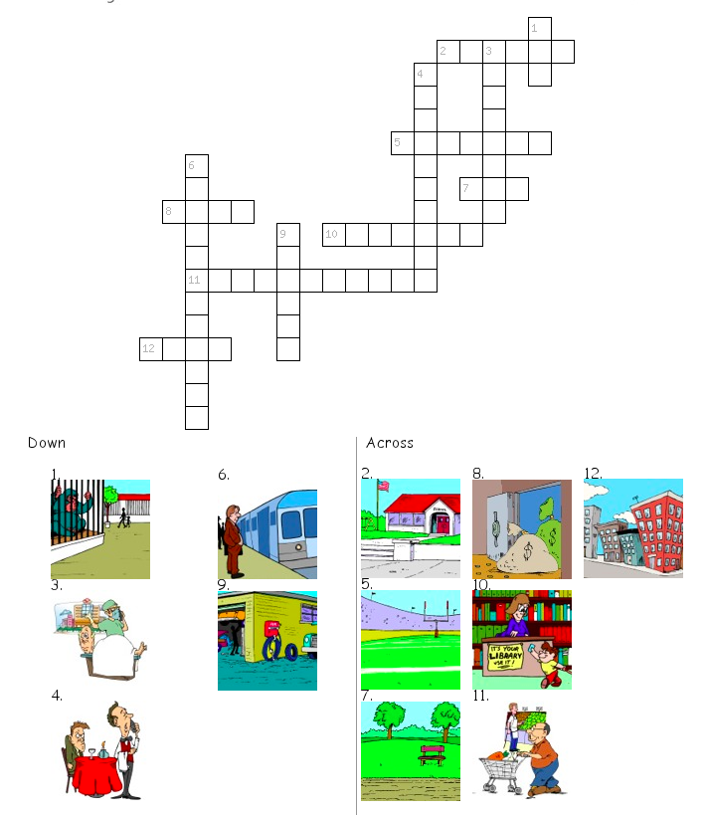

**MY CITY**

Do the crossword.