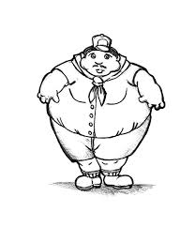  1.  Tick correct option.  a-My brother is heavy.  b-My aunt is heavy.  c-My father is short. | 2.  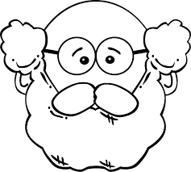  a- My grandmother is old.  b- My grandpa is old.  c- My grandma is thin. | 3. 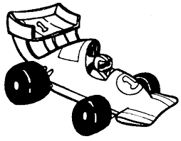  a- It is a fast car.  b- It is a slow car.  c- It is a fast dog.
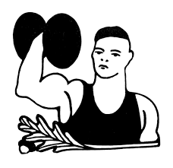  4.  a- She is strong.  b- He is thin.  c- He is strong. | 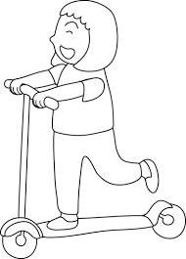  5.  a-My sister is old.  b- My sister is tall.  c- My sister is short. | 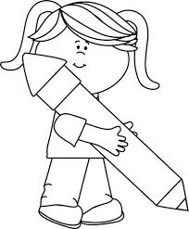  6.  a- My pencil is small.  b- My pencil is big.  c- My book is big.
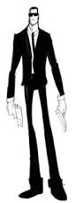  7.  a-Bob is tall and thin.  b- Bob is old and heavy.  c- Bob is short and big. | 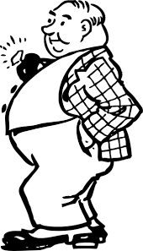  8.  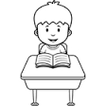  a- My teacher is small.  b- My teacher is heavy.  c- My teacher is thin. | 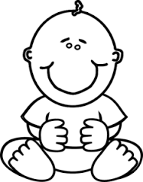  9.  a- Baby is weak.  b- Baby is old.  c- Baby is big.
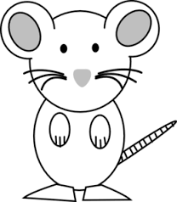  10.  a- The mouse is small.  b- The mouse is big.  c- The mouse is tall. | 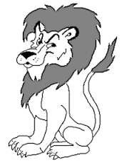  11.  a- The lion is weak.  b- The lion is strong.  c- The lion is slow. | 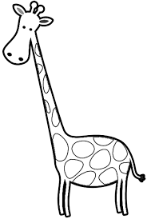  12.  a-The giraffe is short.  b- The giraffe is small.  c- The giraffe is tall.
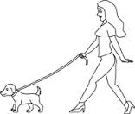  13.  a- My dog is big.  b- My dog is small.  c- My dog is heavy. | 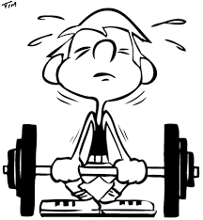  14.  a- He is weak.  b- She is heavy.  c- He is strong. | 15.  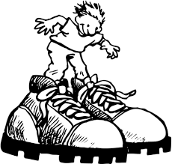  a- My shoes are short.  b- My shoes are thin.  c- My shoes are big.

